E-Ballots

E-balloting means that instead of going to a ballot table to find a schematic and grab your ballot, you will get a notification on your phone sending you directly to your round. After the round when you’ve made your decision, you just enter it directly into the tab system. Neat, clean and fast! Plus, the ballots go on line for the debaters to consult later—no more lost ballots.

The first step in casting e-ballots is to register with tabroom.com. It is best to do this in advance of the tournament.

- Go to Tabroom.com
- Click Sign Up in the top right corner to create an account.

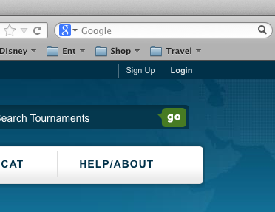

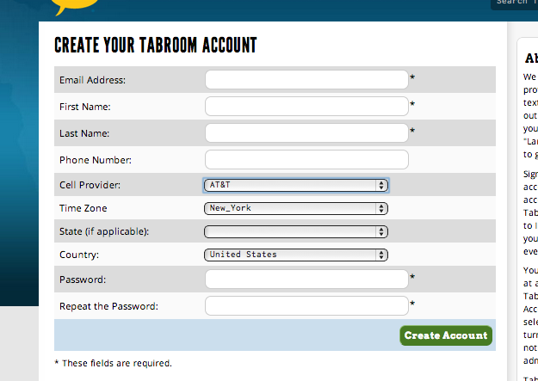
- Once an account is created, click Link your account to a judge under the Your Account header.

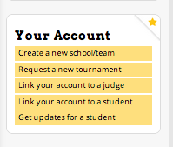

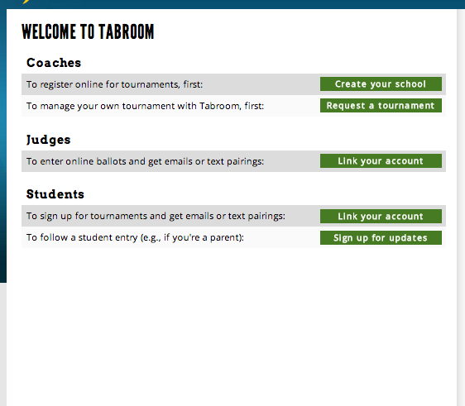

- Search for your judge record within the tournament you’re attending to connect your account.

As soon as you arrive at a tournament, connect to the wireless network.

Instructions for Newark:

- Log onto the server NPS-Guest
- Open your browser and navigate anywhere on the web. This will bring up the dialogue box to connect.
- If you are asked whether to trust the network or to allow the server access to your computer, click yes and allow until you get to a login screen.
- Username: sphguest
- Password: w8380n

After the tournament starts, you will get notifications whenever you have a ballot.

- Go to your assigned room.
- After the competitors arrive, go to tabroom.com. The ballot assignment page will be the first thing to pop up. When everyone is ready (and the sides are determined and set in PF), click START ROUND and the round can begin. This will let the tab room know that everyone is there and accounted for.
- As soon as the round is over and you have made your decision, click on the ENTER button to submit your results. YOU MUST CONFIRM THE RESULTS AS DIRECTED.
- RFDs and comments to the debaters should be entered after you've submitted the results (and even later, if you're rushing to your next assignment).

